**Gym Management System**

**Prepared By: T.Y.M.sc.(C.A & I.T) (2015-2016)**

**1. Halani Dip N.**

**2.Rathod Saurabh K.**

**Gym Management System**

**BY 3RD YEAR. MSC (CA&IT)(2015-2016)**

|  |  |
| --- | --- |
| **Student Name** | **Roll No** |
| Halani Dip N. | 3186 |
| Rathod Saurabh K. | 3222 |
|  |  |

***NAME OF COMPANY***

**Digimation**

***REPORT SUBMITTED TO***



**K.S Schoolof Business Management and Research**

**Date of Submission**: 21rdApril, 2016.

**Project Coordinator**

Mr. Hitesh Paramar

**ACKNOWLEDGEMENT**

Knowledge is a continuous Process. Knowledge has power. It has been said knowledge is end only with life end. But Knowledge is not only acquisition of fact and figures. It is a continuous process of acquiring wisdom though practical education.

This project is an outcome of infinite encouragement. We group member would like to express our sincere gratitude to the Master of Science in Computer Application and Information Technology for introducing the project work in our application.

Our sincere thanks to *Mr. Hitesh Paramar*, joint Director of institute for encourage such project to our field of study. We also thanks to our Project coordinate *Mr. Hitesh* Paramarfor providing guidance and support during this project.

We extend our sincere thanks to our project guider of Digimation. For accommodating me in the project and having faith in me.

Our special thanks to the faculty of *K.S.S.B.M Institute of MSC (CA&IT)* whose co-operation and inspiration, our endeavour would not have met with success.

**From,**

**Dip Halani**

**Saurabh Rathod**

|  |  |  |  |  |
| --- | --- | --- | --- | --- |
| **No**  **INDEX** | **Table Of Contents** | | | **Page No** |
| **1** | **Company Profile** | | | **05** |
| **2** | **Project Profile** | | | **06** |
|  | **2.1** | | Project Definition |  |
|  | **2.2** | | Current System |  |
|  | **2.3** | | Proposed System |  |
| **3** | **System Requirement And Specification** | | | **07** |
| **4** | **System Design** | | | **08** |
|  | **4.1** | Use Case Diagram | |  |
|  | **4.2** | Class Diagram | |  |
|  | **4.3** | Activity Diagram | |  |
|  | **4.4** | Sequence Diagram | |  |
|  | **4.5** | Data Dictionary | |  |
| **5** | **Input-Output Design(Screen Shoats)** | | | **23** |
| **6** | **Testing** | | | **33** |
| **7** | **Conclusion(Future Scope, Limitation)** | | | **37** |
| **8** | **Bibliography** | | | **39** |

**1. Company Profile**

***Digimation*** started with the goal to march forward in various faces with novel ideas. We strongly believe that every creation follows the strategically strong principles and the innovative judgments. Our great asset – skilled professionals, make us ever growing organization. By maintain long lasting relations with people and technology, we have gained the place of global admirer and a fair business entity. Timely achievement of targets and professionally qualitative results is our true identity. We deliver admirable results by incorporating the lessons from the past projects and adventures.

***We have the key capabilities in the fields of:***

* Web Development
* Research & Market Analysis
* Offshore Development
* QA outsourcing
* Networking

***We have dedicated professionals in following areas,***

* JQuery Mobile
* Android
* PHP
* .NET
* Java

We have enthusiastic team with long term steadiness which makes it possible to commit the timely results. Our team follows time tested procedures and structures for development. Our customers are completely involved in all the phases of product development and hence we are able to maintain the lucidity in our developments. For project development we follow responsive development strategies from the very beginning stage of planning to deployment and hosting.

**2. Project Profile**

**2.1 Project Definition**

In this website people can know the information about a gym. User can see their

Schedule, Progress card, Package and get their I-Card. Trainer can see their schedule

And generate member’s progress card.

**2.2 Current System**

* People Need To Ask For Schedule Or Have To Visit Particular Place.
* Progress Card Is Manually Obtained
* People can get their gym related information anytime and anywhere.

**2.3 Proposed System**

* People can see schedule anytime
* People can see theirt progress card
* People can see information about the gym

**3. System Requirement and Specification**

**3.1 Hardware Requirement**

Processor : Minimum Pentium

RAM : 128 MB or More

**3.2 Software Requirement**

Web Browse

**3.3Technology Used**

***3.3.1Frontend Technology***

* + - JSP-Servlet:
    - HTML5:
    - CSS:
    - JQUERY:

3.3.2**Frontend Tools:**

* Dreamweaver CS6
* Photoshop CS6
* Eclipse
  + 1. ***Backend Technology:***
* MYSQL:

**3.3.4 Backend Tools**

* + MySQL
    1. **Web server**
  + Apache Tomcat 7

**3.3.6Testing Tools:**

* + Firebug

**System Design**

**11s;dlfkmfklrlm**

**4. System Design**

1. **Use Case Diagram**

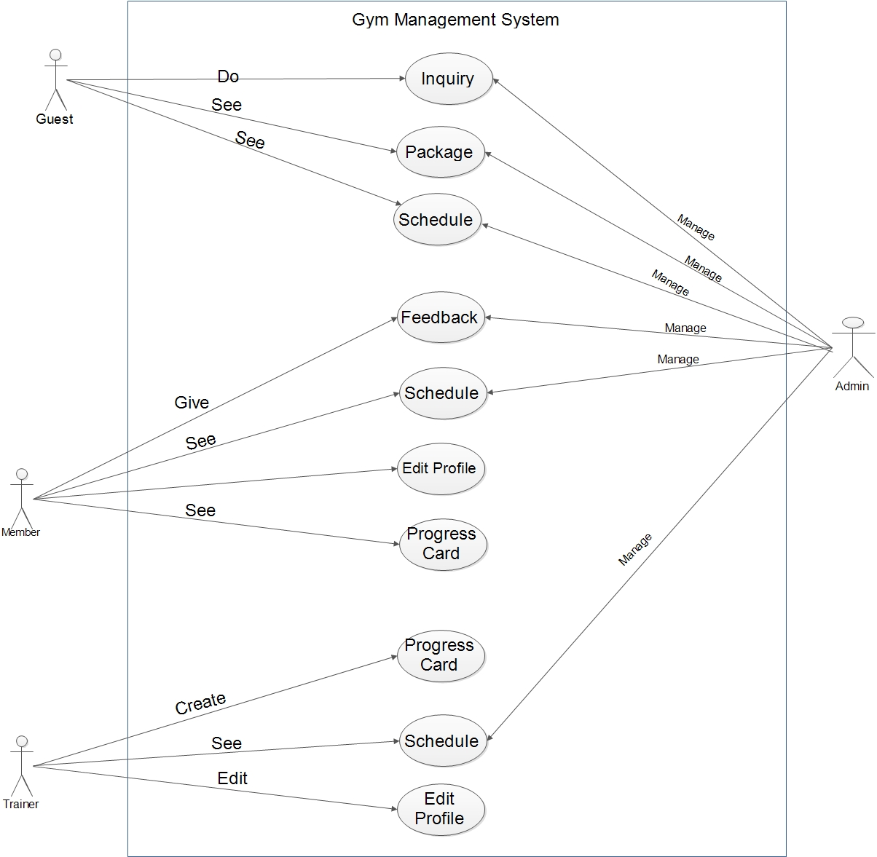

1. **Class Diagram**

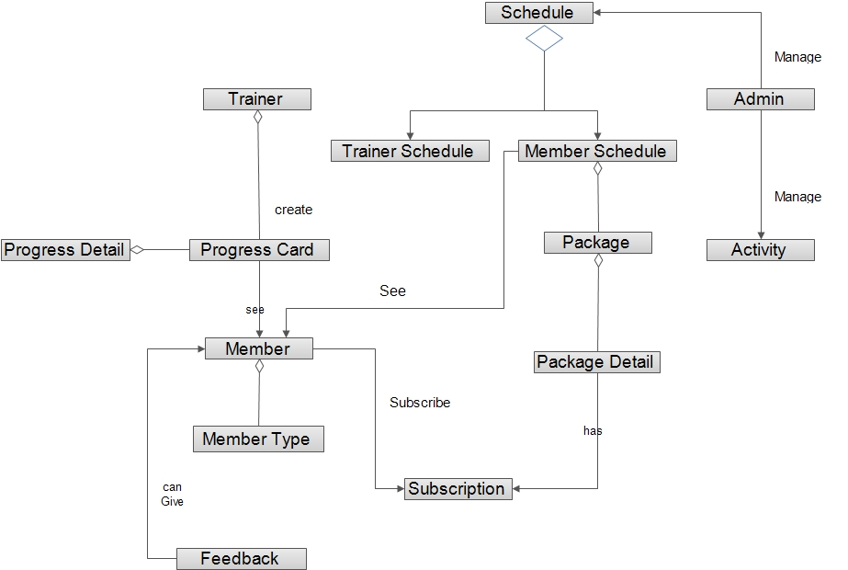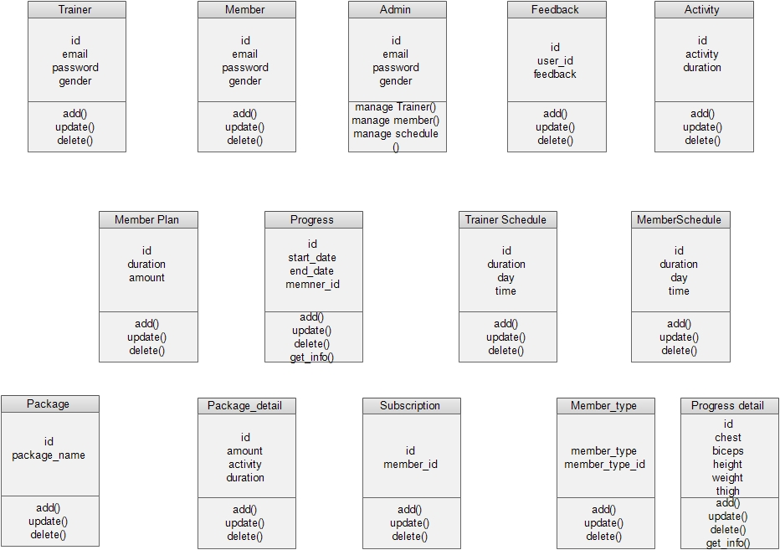

1. **Activity Diagram**

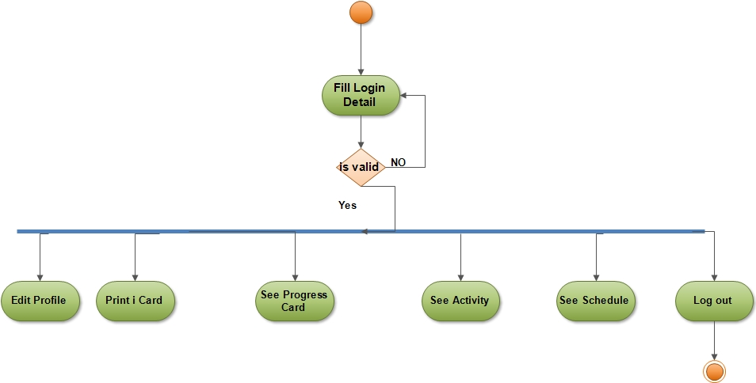

1. **Sequence Diagram**

**Admin**

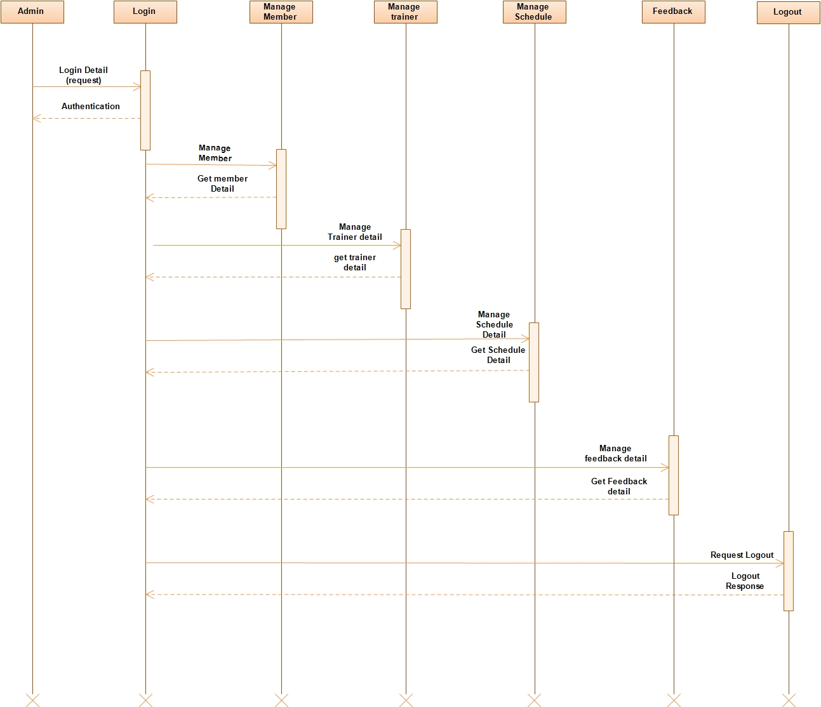

**Trainer**

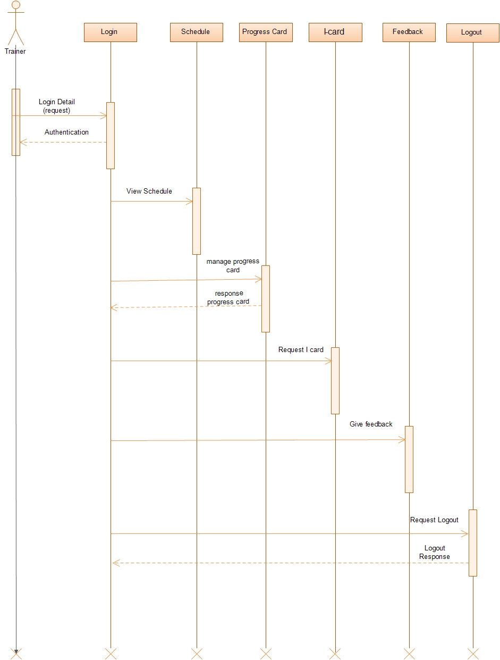

**Member**

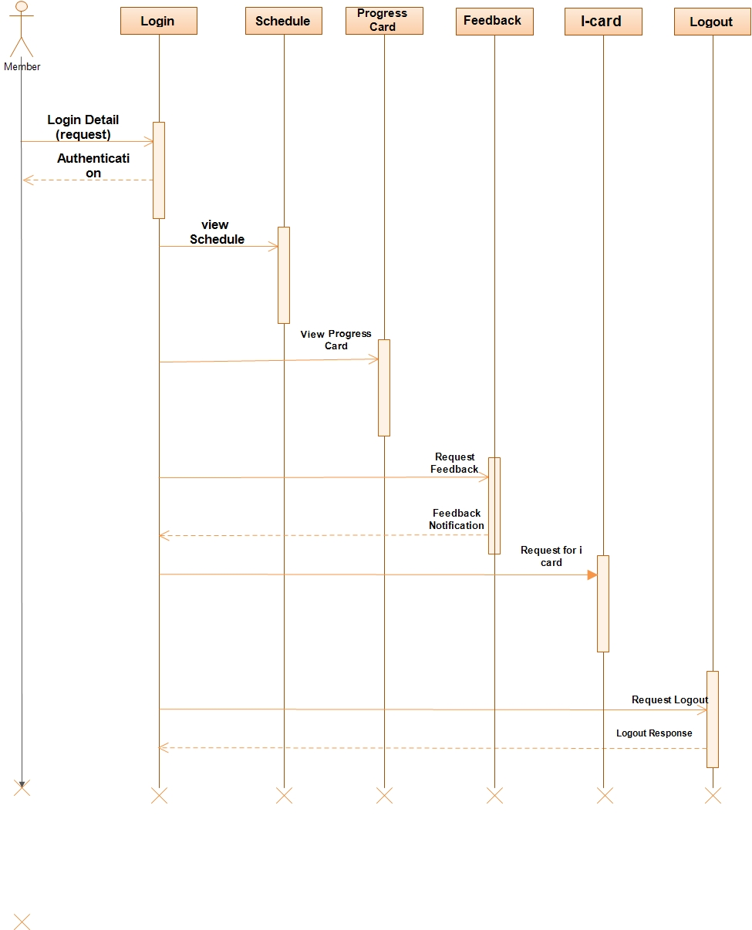

**Data Dictionary**

Table 1:

Admin

|  |  |  |  |  |
| --- | --- | --- | --- | --- |
| Field Name | Data Type | Size | Constraints | Description |
| Admin_id | int | 5 | Primary key, Auto increment | Id of Admin. |
| First_name | varchar | 15 | Not Null | First name of Admin. |
| Last_name | varchar | 15 | Not Null | Last name of Admin. |
| Email | varchar | 30 | Unique, Not Null | Email-id of Admin. |
| Gender | char | 1 | Not Null | Gender of Admin. |
| Mobile | varchar | 10 | Unique | Admin Phone No. |
| Password | text | - | Not Null | Password of Admin |
| Is_active | char | 1 | Not Null | Admin is Active or Not |
| City_id | int | 3 | FK | Reference of CityId |

Table 2:

Member

|  |  |  |  |  |
| --- | --- | --- | --- | --- |
| Field Name | Data Type | Size | Constraints | Description |
| Member_id | Int | 10 | Primary key, Auto increment | Id of Member |
| Member_type_Id | Tinyint | **2** | FK | From Member_type |
| First_name | Varchar | 15 | Not Null | First name of Member |
| Last_name | Varchar | 15 | Not Null | Last name of Member |
| Email | Varchar | 30 | Unique, Not Null | Email-id of Member |
| Gender | Char | 1 | Not Null | Gender of Member |
| DOB | Date | - | Not Null | Member Birthdate. |
| Address | Varchar | 100 | Not Null | Address of Member |
| Mobile | Varchar | 10 | Unique, Not Null | Member Phone No. |
| Password | Text | - | Not Null | Encrypted Password of Member |
| Is_active | Char | 1 | Not Null | Member is Active or Not |
| City_id | Int | 3 | FK | Reference of CityId |

Table 3:

Trainer

|  |  |  |  |  |
| --- | --- | --- | --- | --- |
| Field Name | Data Type | Size | Constraints | Description |
| Trainer_id | Int | 10 | Primary key, Auto increment | Id of Trainer |
| First_name | Varchar | 15 | Not Null | First name of Trainer |
| Last_name | Varchar | 15 | Not Null | Last name of Trainer |
| Email | Varchar | 30 | Unique, Not Null | Email-id of Trainer |
| Gender | Char | 1 | Not Null | Gender of Trainer |
| DOB | Date | - | Not Null | Trainer Birthdate. |
| Address | Varchar | 100 | Not Null | Address of Trainer |
| Mobile | Varchar | 10 | Unique, Not Null | Trainer Phone No. |
| Password | Text | - | Not Null | Password of Trainer |
| Experience | Tinyint | 2 | Not Null | Experience of Trainer |
| Is_active | Char | 1 | Not Null | Trainer is Active or Not |
| City_id | Int | 3 | FK | Reference of CityId |

Table 4:

Member_Type

|  |  |  |  |  |
| --- | --- | --- | --- | --- |
| Field Name | Data Type | Size | Constraints | Description |
| Member_type_id | Int | 3 | PK | Member Type Id |
| Member_type | Varchar | 20 | Not null | Type of Member |

Table 5:

Progress

|  |  |  |  |  |
| --- | --- | --- | --- | --- |
| Field Name | Data Type | Size | Constraints | Description |
| Progress_id | Int | 5 | PK | Progress_id |
| Member_id | Int | 5 | Not null,FK | Member id |
| Start_date | Date | - | Not null | Start_Date |
| End_Date | Date | - | Not null | End_Date |

Table 6:

Progress_Detail

|  |  |  |  |  |
| --- | --- | --- | --- | --- |
| Field Name | Data Type | Size | Constraints | Description |
| Progress_Detail_id | Int | 5 | PK | Id of Progress_Detail |
| Progress_id | Int | 5 | PK | Id of Progress |
| Height | Double | 10,1 | Not Null | Height of Member |
| Weight | Double | 10,1 | Not Null | Weight of Member |
| Biceps | Double | 10,1 | - | Biceps of Member |
| Thigh | Double | 10,1 | - | Thigh of Member |
| Forearms | Double | 10,1 | - | Forearms of Member |
| Chest | Double | 10,1 | - | Chestof Member |
| Date | Date | - | Not null | Date |

Table 7

Schedule_Time

|  |  |  |  |  |
| --- | --- | --- | --- | --- |
| Field Name | Data Type | Size | Constraints | Description |
| Schedule_time_id | Tinyint | 2 | Primary key, Auto increment | Id of schedule |
| Start_time | Time | - | Not Null | Starting Time |
| End_time | Time | - | Not Null | Ending Time |

Table 8

Schedule

|  |  |  |  |  |
| --- | --- | --- | --- | --- |
| Field Name | Data Type | Size | Constraints | Description |
| Schedule_id | Int | 5 | Primary key, Auto increment | Id of schedule |
| Schedule_Time_id | Int | 5 | FK,not null | From Schedule_Time table |
| Activity_id | Int | 2 | FK,not null | Id of MemberActivity |
| Off_day1 | Tinyint | 1 | Not null | Off_Day1 of Schedule |
| Off_day2 | Tinyint | 1 | - | Off_Day2 of Schedule |

Table 9:

Member_Schedule

|  |  |  |  |  |
| --- | --- | --- | --- | --- |
| Field Name | Data Type | Size | Constraints | Description |
| Member_Schedule_id | Int | 5 | Primary key, Auto increment | Id of schedule_detail |
| Schedule_id | Int | 5 | Fk,not null | From Schedule Table |
| Member_id | Int | 5 | FK,not null | From Member table |
| Trainer_id | Int | 5 | FK,not null` | From Trainer Table |

Table 10:

Trainer_Schedule

|  |  |  |  |  |
| --- | --- | --- | --- | --- |
| Field Name | Data Type | Size | Constraints | Description |
| Trainer_Schedule__id | Int | 5 | Primary key, Auto increment | Id of schedule |
| Trainer_id | Int | 5 | FK,not null | From Trainer table |

Table 11:

Activity

|  |  |  |  |  |
| --- | --- | --- | --- | --- |
| Field Name | Data Type | Size | Constraints | Description |
| ActivityId | TinyInt | 2 | Primary key, Auto increment | Id of day |
| Activity_name | Varchar | 20 | Not Null, unique | Activity Name |

Table 12:

City

|  |  |  |  |  |
| --- | --- | --- | --- | --- |
| Field Name | Data Type | Size | Constraints | Description |
| City_id | Int | 5 | Primary key, Auto increment | Id of Gym |
| City_name | Varchar | 30 | Unique,Not Null | Name of City |

Table 13:

Inquiry

|  |  |  |  |  |
| --- | --- | --- | --- | --- |
| Field Name | Data Type | Size | Constraints | Description |
| Inquiry_id | Int | 5 | Primary key, Auto increment | Inquiry_id for Member |
| First_name | varchar | 15 | Not Null | First Name of User |
| Last_name | varchar | 15 | Not Null | Last Name of User |
| Email | varchar | 30 | Unique,not null | Email of User |
| Mobile | varchar | 10 | Unique,not null | Phone no of User |
| Massage | Text | - | Not null | Content of User |
| Date | date time | **-** | Not Null | The date of inquiry |
| Is_read | Char | 1 | Default ‘n’ | Is inquiry read or not |

Table 14:

Feedback

|  |  |  |  |  |
| --- | --- | --- | --- | --- |
| Field Name | Data Type | Size | Constraints | Description |
| Feedback_id | Int | 5 | Primary key, Auto increment | Id of Feedback. |
| Date | Date | - | Not null | The date of FeedBack |
| User_id | int | 5 | FK | User id |
| Feedback | Text | - | Not Null | Content of feedback |

Table 15:

Package

|  |  |  |  |  |
| --- | --- | --- | --- | --- |
| Field Name | Data Type | Size | Constraints | Description |
| Package_id | Int | 5 | Primary key, Auto increment | Package Id |
| Name | Varchar | 20 | Not null,unique | Package Name |
| Duration | Tinyint | 1 | Not null | Duration |

Table 16:

Package_Detail

|  |  |  |  |  |
| --- | --- | --- | --- | --- |
| Field Name | Data Type | Size | Constraints | Description |
| Package_detail_id | Int | 5 | Primary key, Auto increment | Package_detail Id |
| Package_id | Int | 5 | FK,not null | Form table Package |
| Activity_id | Tinyint | 2 | FK,Not null | From Activity Table |
| Amount | Int | 5 | Not null | Amount |
| Member_type_id | Tinyint | 2 | FK,not null | From table Member_type |

Table 17:

Subscription

|  |  |  |  |  |
| --- | --- | --- | --- | --- |
| Field Name | Data Type | Size | Constraints | Description |
| Subscription_id | Int | 5 | PK | Id of subscription |
| Package_detail_id | Int | 5 | FK | From table Package_detail |
| Member_id | Int | 5 | FK,not null | Form table Member |
| Start_Date | Date | - | Not null | Start date of subscription |
| End_Date | Date | - | Not null | End date of subscription |

**Input Output Design**

1. Home Page

**5.Input-Output Design**



1. **Gym Trainer Information**

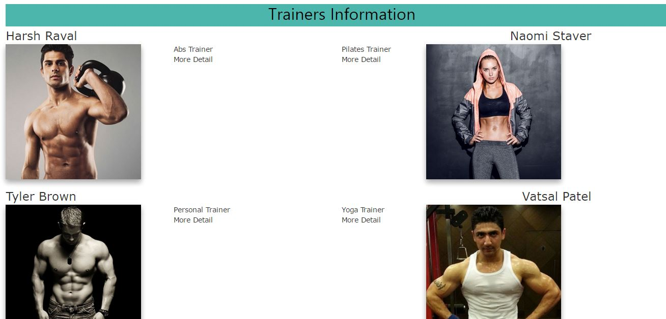

1. **Stretching information**

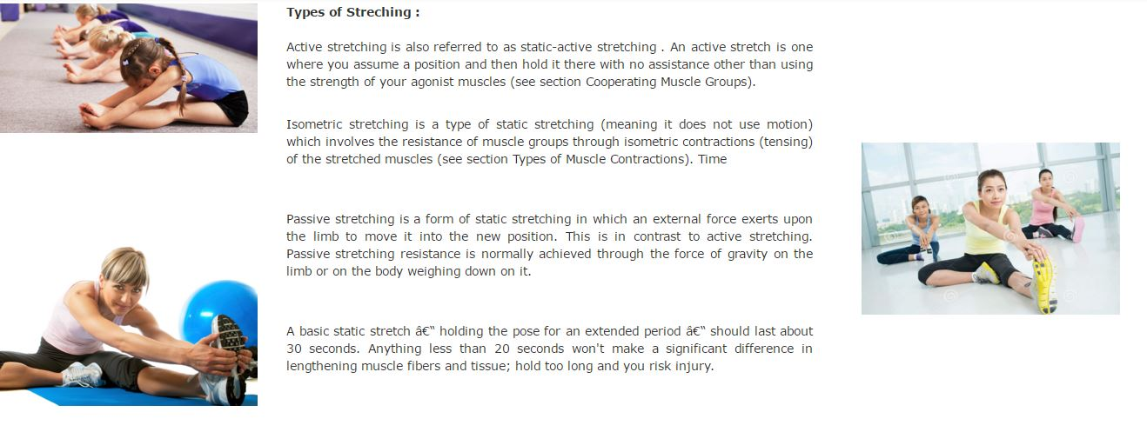

1. **Yoga Information**

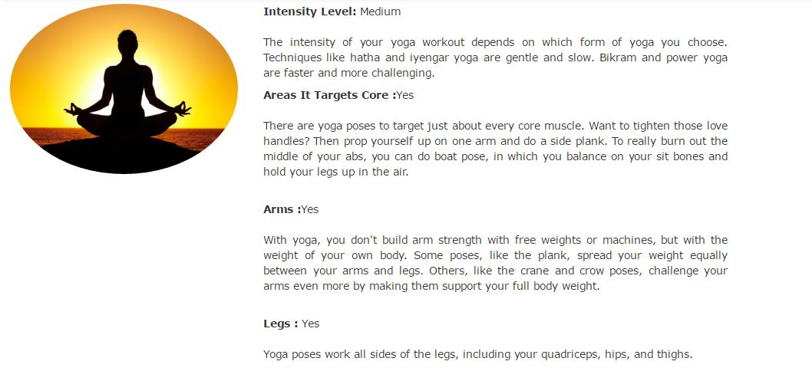

1. **Equipment’s**

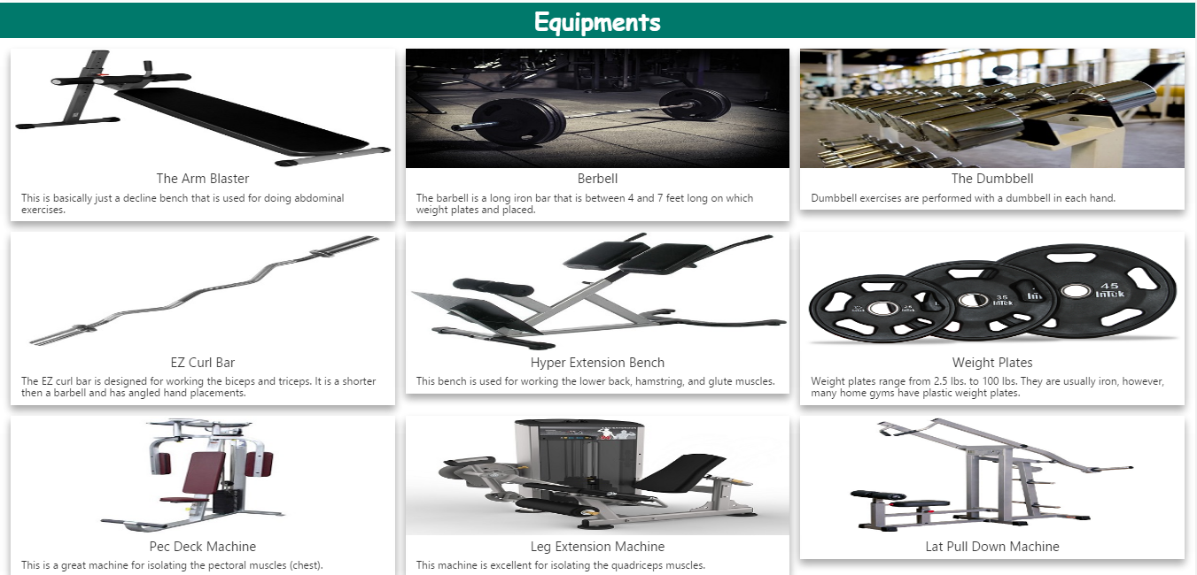

1. **Guest Inquiry**

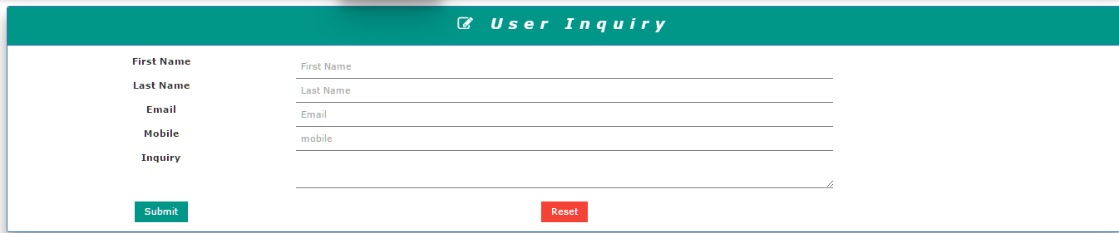

1. **Login Page**

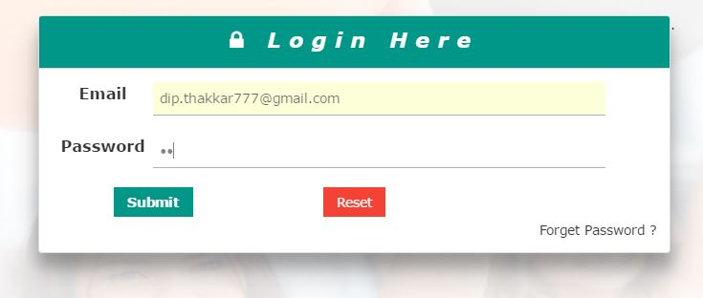

1. Member Progress Card

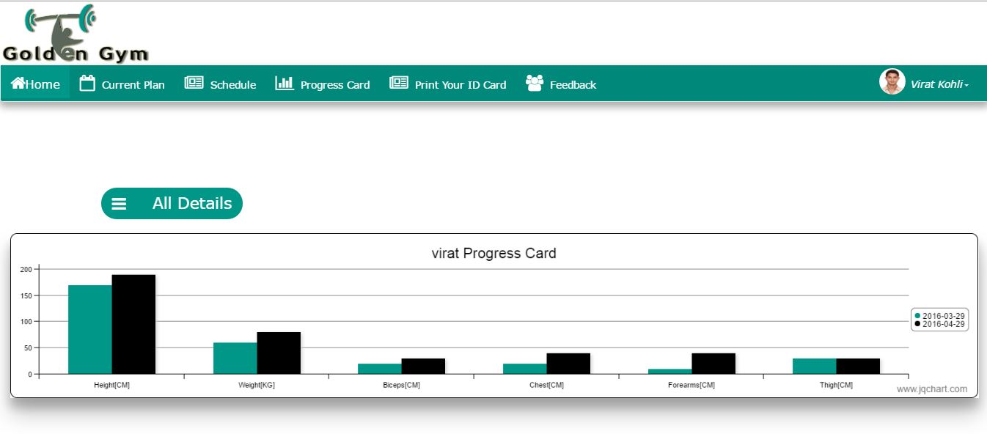

1. **Member Current Plan**

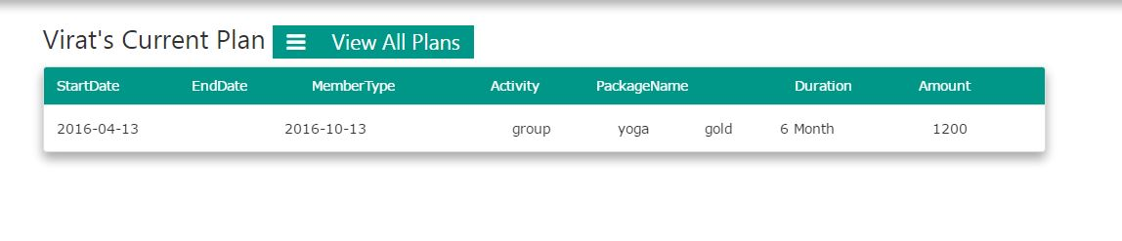

1. **Member I-Card**

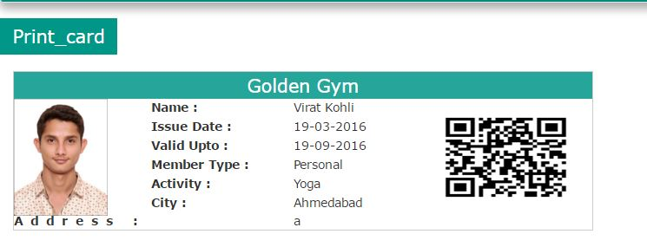

1. **Current Plan**
2. **Member Schedule**

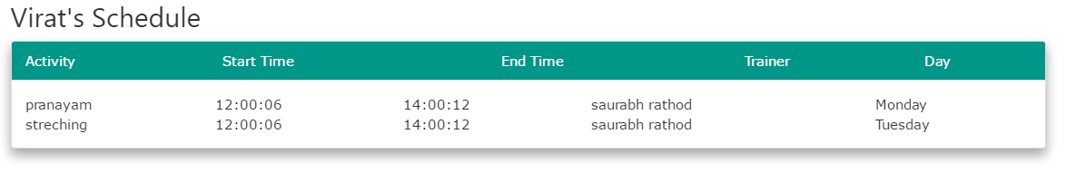

1. Member Option Menu

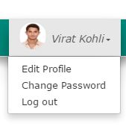

1. **Member Edit Profile**
2. **Member Change Password**

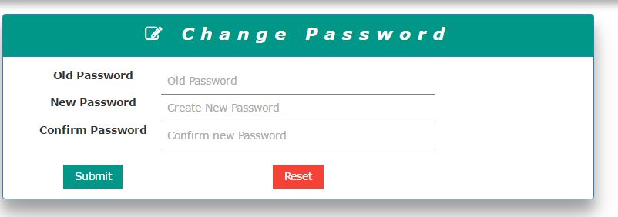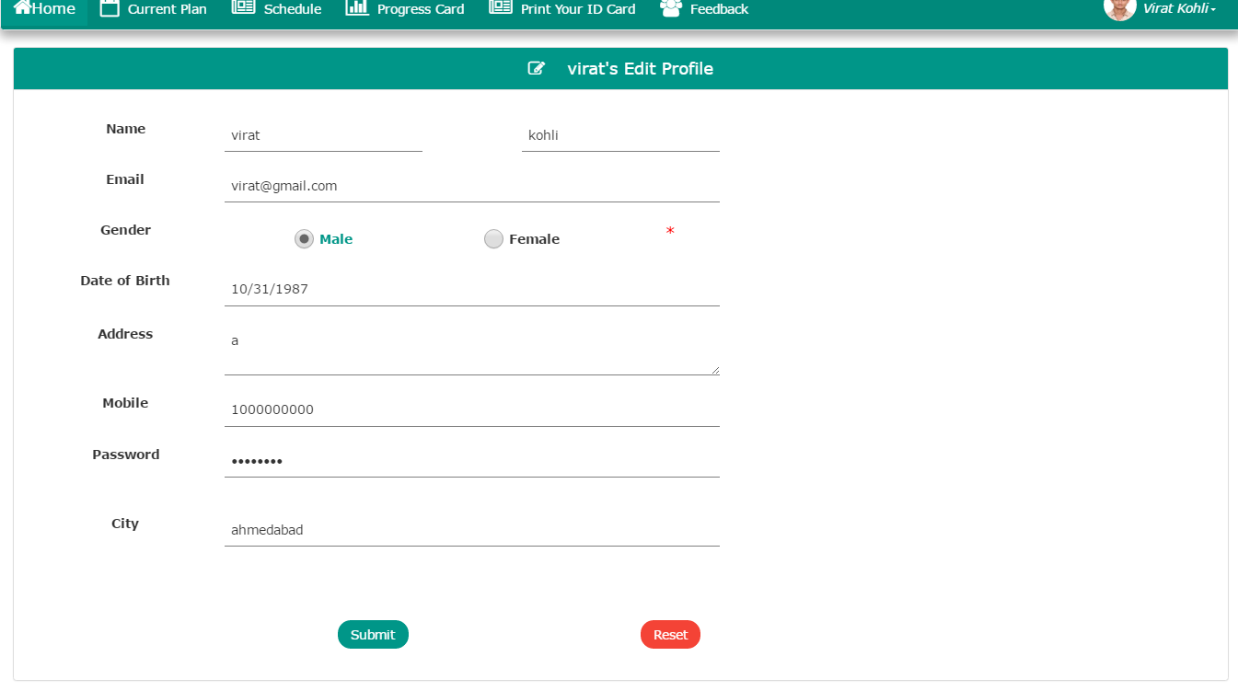

1. 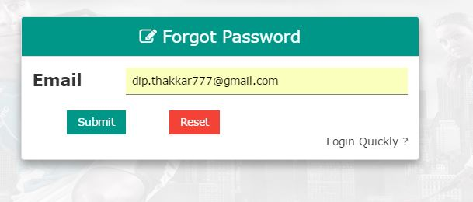**Forget Password**

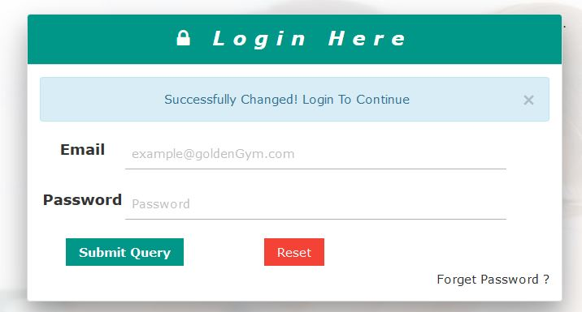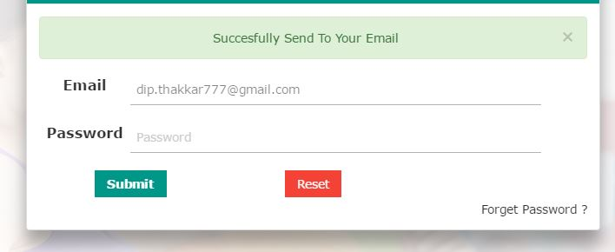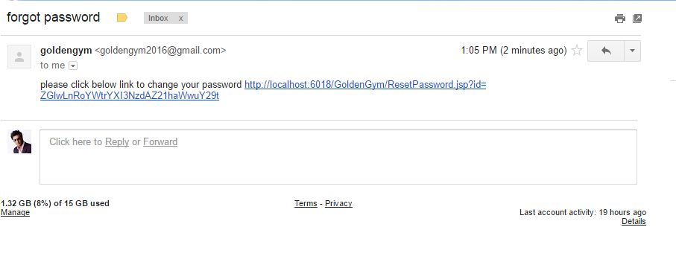

1. **Admin dashboard**

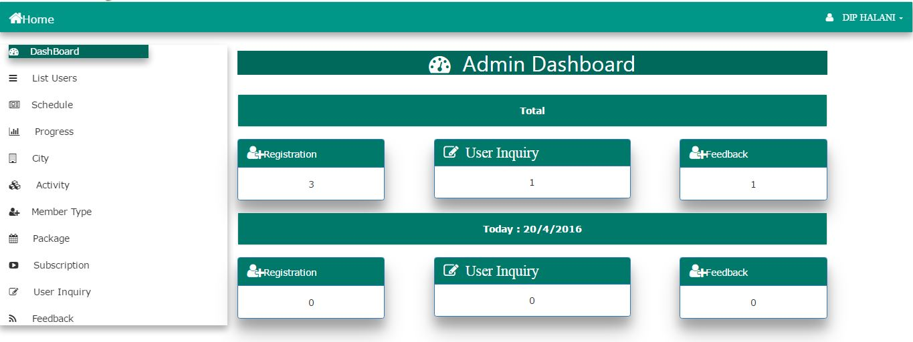

1. **List View**

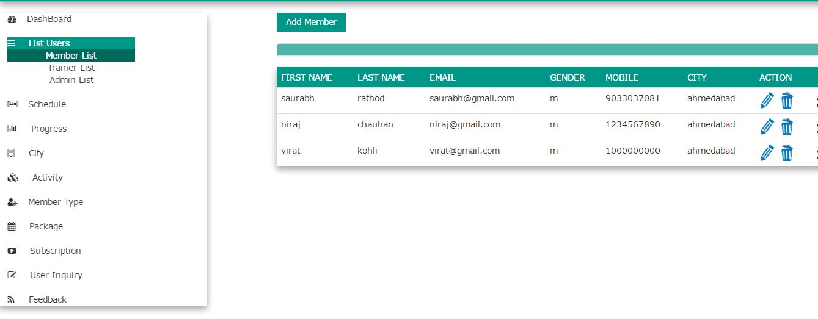

1. **Admin Option**

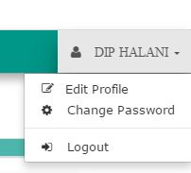

1. **Package list**
2. **Progress card**

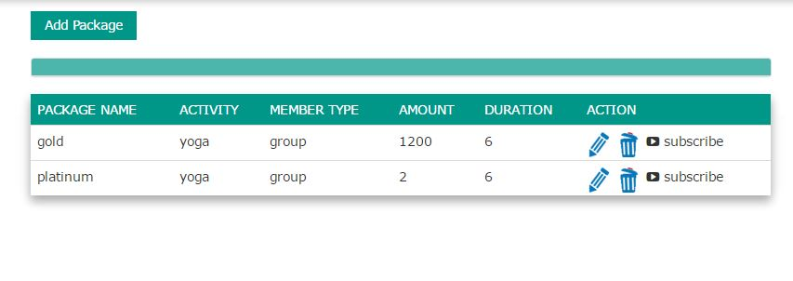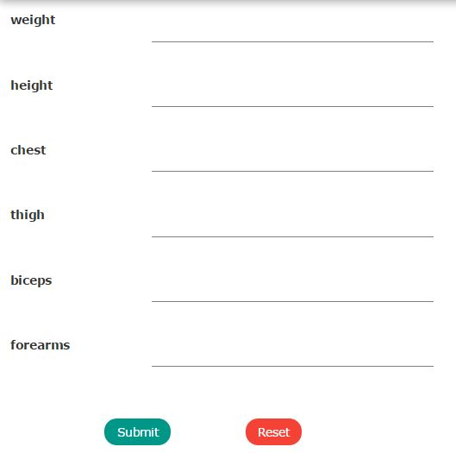

**Testing**

1. **Index Validation**

**6. Testing**

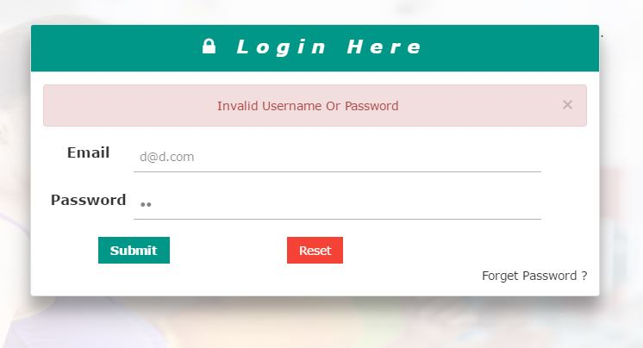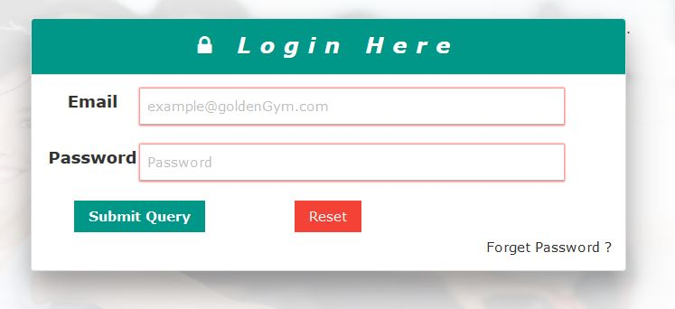

1. **Form Validation**

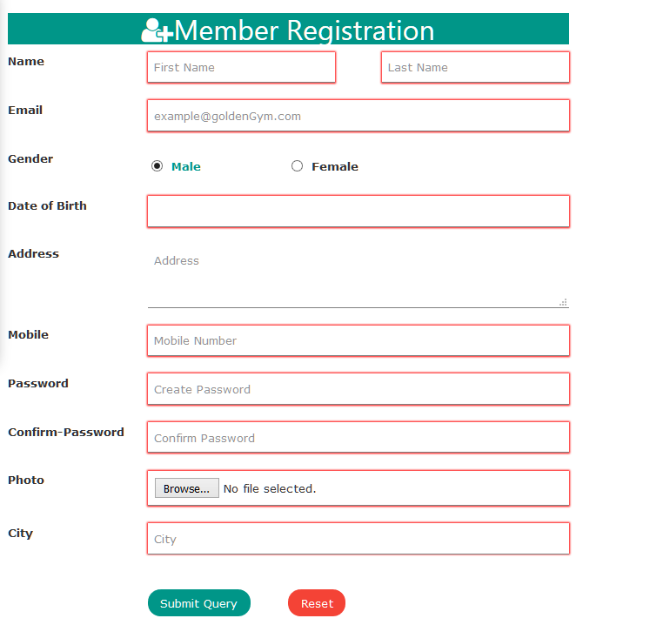

1. Validate Forget Password

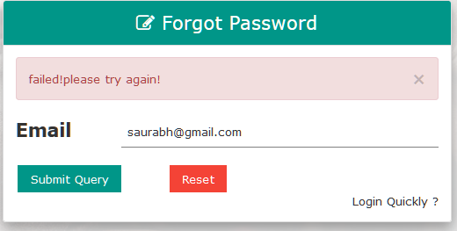

1. Reset Password

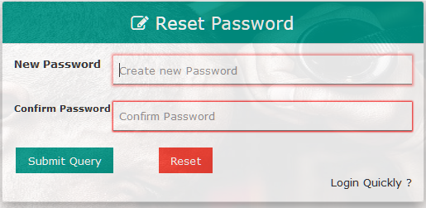

**7.Future Scope**

* Our Current system does not provide diet plan
* We will Provide Online payment

**7.Conclusion**

**Any Work may not always be perfect:**

­­­­­­­There may be some defects or errors. We have taken enough care to make the project user friendly and more interactive.

**Any suggestion to make this project more useful is Always most welcome.**

**8. Bibliography**

**Reference sites**:

* + www.jquery.com
  + www.w3schools.com
  + [www.stackoverflow.com](http://www.stackoverflow.com)
  + Viralpatelqrcode.com

**Thank you…**